**React native environment setup**

------------------------------------------------------------------------------------------------------------------------------------------

*First of All, I use chocolatey using command:*

Set-ExecutionPolicy Bypass -Scope Process -Force; [System.Net.ServicePointManager]::SecurityProtocol = [System.Net.ServicePointManager]::SecurityProtocol -bor 3072; iex ((New-Object System.Net.WebClient).DownloadString('https://chocolatey.org/install.ps1'))

Remember that, I use here windows power shell ran as administrator. Then, use this command.

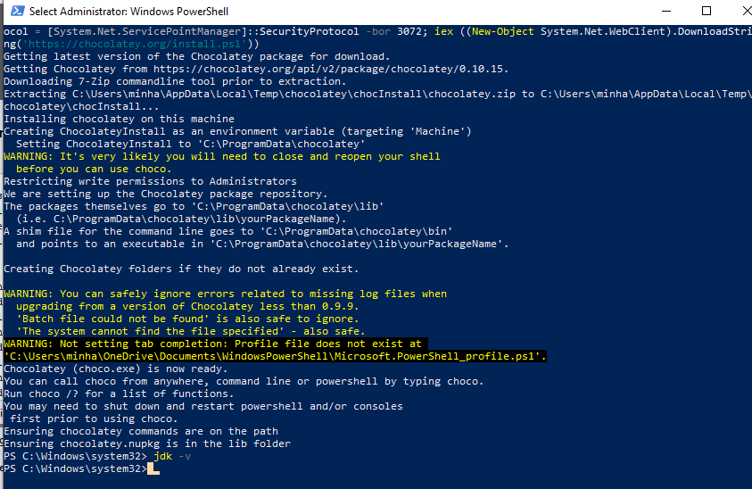

**After complete this command I start here another command:**

Install node, python, SDK use this command:

choco install -y nodejs.install python3 jdk14

or

choco install -y nodejs.install python3 jdk14 --force

**Now I set android studio**

Download android studio and install it. Here I observe some fact.

Android studio.exe file I install normally.

Now, SDK set up is

- android 9.0 pi should install.

- Intel x86 Atom System Image revision 6

- Android SDK Build-Tools 28.0.3 version 28.0.3

This three is must require for android development. Otherwise I have to face error.

Here is step screenshot.

*My pc hidden file show not enable that’s why do this steep.*

*Click windows button and type folder and click it.*

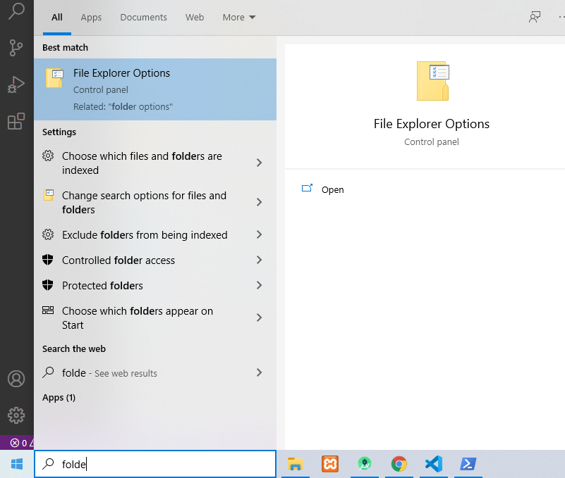

*Now I seen this window choose view option.*

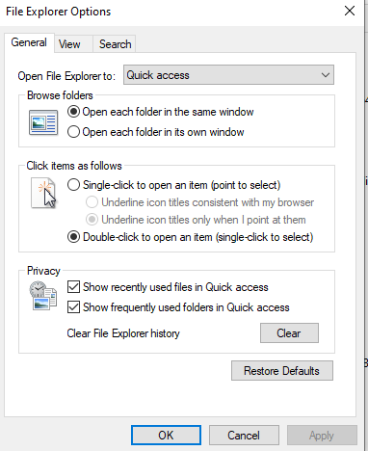

*Okay so I see here Hidden files and folders so enable show hidden files and folder.*

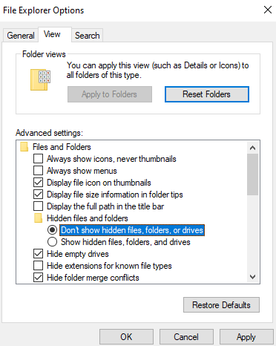

**

*Now go to c:/ drive then users then username then AppData folder then local then Android now Sdk*

**

*Copy this path and click window button and type environment. Now show this window and click this.*

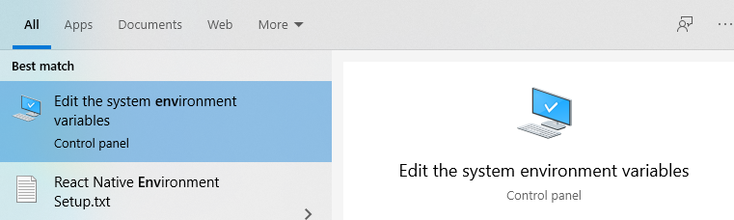

*Now I see this window and I click Environment Variables.*

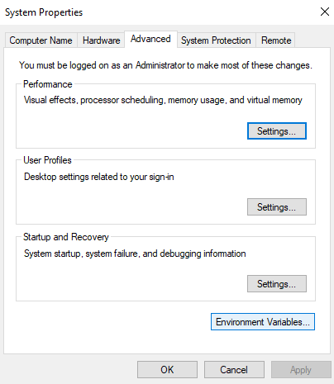

*Then show this window and now click New.*

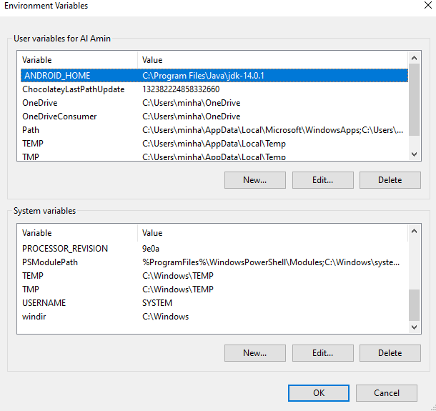

*Then show this window*

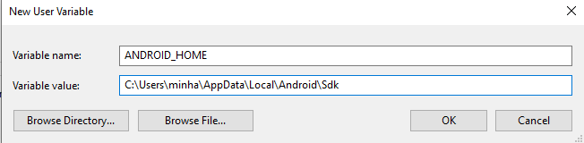

*Now here I pest my copied path.*

**

*Now apply/ok.*

Now I set Add platform-tools to path

.